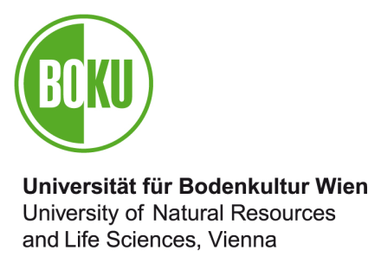

To:
Arbeitskreis für
Gleichbehandlungsfragen
(Equal Opportunities Working Party)
Universität für Bodenkultur Wien
Gregor-Mendel-Straße 33
1180 Wien

Inge Dirmhirn Scholarship

for the Promotion of a Master Degree
at the University of Natural Resources and Life Sciences, Vienna 2021

Application form
Topic of the planned master thesis:

Applicant
Title | Academic title
Last name | First name
Date of birth (TT/MM/JJ)

Residential address:  Street | Post code: | Town:
Email: | Telephone::

Examination subject / academic specialisation to which the master thesis belongs:

Supervisors of master thesis

Supervisor
Last name, first name, academic title, subject, institute/department

Co-supervisor
Last name, first name, academic title, subject, institute/department

(please tick the appropriate box)

An employment relationship with the University of Natural Resources and Applied Life Sciences Vienna (BOKU)
currently exists until (DD/MM/YY) indefinite employment relationship
is planned for 2022.
There is currently no employment relationship.
is not planned for 2022.

Bank details of applicant:

Bank name:
Bank routing number (BLZ): IBAN:

Account number: BIC:

Declaration by applicant

By signing below I confirm that the information provided here is complete and correct and acknowledge that incorrect information may result in the repayment of any scholarship money granted.

Place, date Signature of applicant

The following documents are attached to the application:

- Curriculum vitae
- Copy of the „Studienblatt“ (student data protocol) showing the enrollment in a Master study program
- Topic of the planned Master thesis including a short description of the Master thesis project with regards to its working hypothesis and objectives.
- Motivational statement of the applicant why this work fulfills the criteria of this scholarship call
- Letter confirming supervision

Applications for this scholarship can be submitted by email exclusively as electronically/digitally PDF documents by November 15, 2021 to: akglboku@boku.ac.at

Applicants will receive a confirmation of their application by email.

