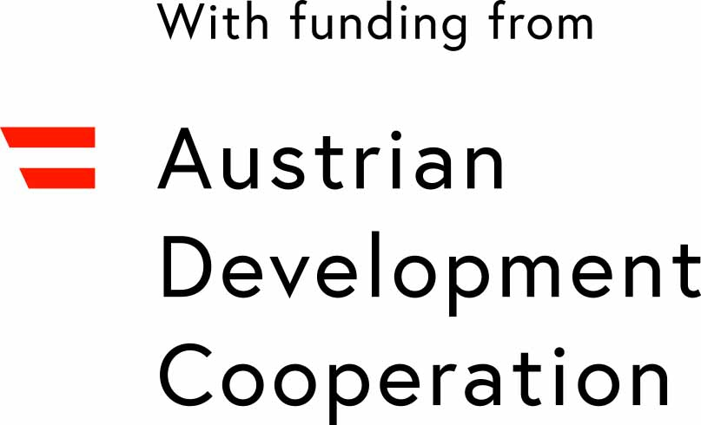
IPGL Office



ADC-FELLOWSHIP APPLICATION FORM
FOR THE
19 to 24-MONTHS JOINT MASTER’S PROGRAMME IN LIMNOLOGY & WETLAND MANAGEMENT

Attach recent photo
Mail to:

IPGL-Office
University of Natural Resources and Life Sciences, Vienna
Department of Water, Atmosphere and Environment
Institute of Hydrobiology and Aquatic Ecosystem Management
Gregor Mendel Str. 33/DG/34
A-1180 Vienna

^{PERSONAL DATA} | 1. Surname First Name (underline name used) male /female
^{PERSONAL DATA} | 2. Official name (i.e. name under which you wish to be registered and which will appear on your certificate)
^{PERSONAL DATA} | 3. Postal address
^{PERSONAL DATA} | Phone Fax E-mail
^{PERSONAL DATA} | 4. Present citizenship Religion
^{PERSONAL DATA} | 5. Profession
^{PERSONAL DATA} | 6. Date, place and country of birth
^{PERSONAL DATA} | 7. Marital status: single / married / divorced / widowed
^{PERSONAL DATA} | 8. Number of children Age of children
^{PERSONAL DATA} | 9. Father alive (yes / no); profession education level
^{PERSONAL DATA} | 10. Mother alive (yes / no); profession education level
^{PERSONAL DATA} | 11. Number of living brothers and sisters how many with higher education (University)
^{PERSONAL DATA} | 12. Person to contact in case of emergency:  Name Relationship
^{PERSONAL DATA} | Address
^{PERSONAL DATA} | 13. Are you simultaneously applying for another fellowship or position? (if any, state field of activity, place  duration and sponsoring institution – use additional sheet if necessary)
^{PERSONAL DATA} | 14. If you do not apply for another fellowship, how do you intend to pay for the costs of the programme?  (Use additional sheet if necessary)
^{PERSONAL DATA} | 15. Statement of the candidate:  I declare that the statements made in this application are true and complete. If selected for a fellowship, I will  return to my home country at the end of my fellowship period.
^{PERSONAL DATA} | Place Date Signature

