A Style template for the PROCEEDINGS of the workshop on 3D Remote sensing in forestry
First Author¹, Second Author² and Third Author³
do not abbreviate first names
¹ University of xxxxxxxxxx, Department of Geography, Town, Country; e-mail
² University of xxxxxxxx, Institute of Physics, Town, Country; email
³ Cyberspace Inc., Town, Country; e-mail
ABSTRACT
The abstract should concisely summarize the key findings of the paper. It should consist of a single paragraph containing no more than 250 words. The Abstract does not have a section number. A list of up to five keywords should immediately follow the Abstract after a blank line.
Keywords: Keyword1, keyword2, keyword3, … , keyword5

Introduction
It is obligatory to use a copy of this file for preparing the manuscript and to use the prepared formats. Up to three levels of headings can be used (“Heading1”, “Heading2”, “Heading3”).
Examples:
  - Heading 2
This is an example of a subsection.
    - Heading 3
This is an example of a sub-subsection.

For sections that are not numbered (“Abstract”, “Acknowledgements” and “References”) use the format “Heading 0”.
Please follow the format of citations as given below and the format of references as given at the end of the document. Use format “List of References” for the references section:
- books (Smith 1987a);
- article in a journal (Smith et al. 1990);
- article in edited books and proceedings (Smith 1987b);
- references from web sites, see example (Moons 1997).

NOTE: The proposed structure of the manuscript given below is only an example but not obligatory.

Methods
This section should describe in detail the study material, procedures and methods used.

Results
Figures, graphs and other illustrations may be shorter and more effective than text, but avoid tables and graphs that duplicate the text. They should be inserted in the text near the place where they are mentioned the first time. See Table 1 and Figure 1 for examples.
All tables must have suitable titles above them.
Table 1: A sample table. Use format Table headings for the table legend, letter style Arial italic 11 pt. Use format Table for the table text, letter style Arial 11 pt, single line spacing with 1 pt spacing before and 1 pt following the paragraph .
Line 1 | Column 2 | Column 3
Line 2
Line 3

Figures should be embedded in the manuscript. Their position should be close to the text paragraphs to which they belong. Figures are centred, and figure legends are placed under the figure.
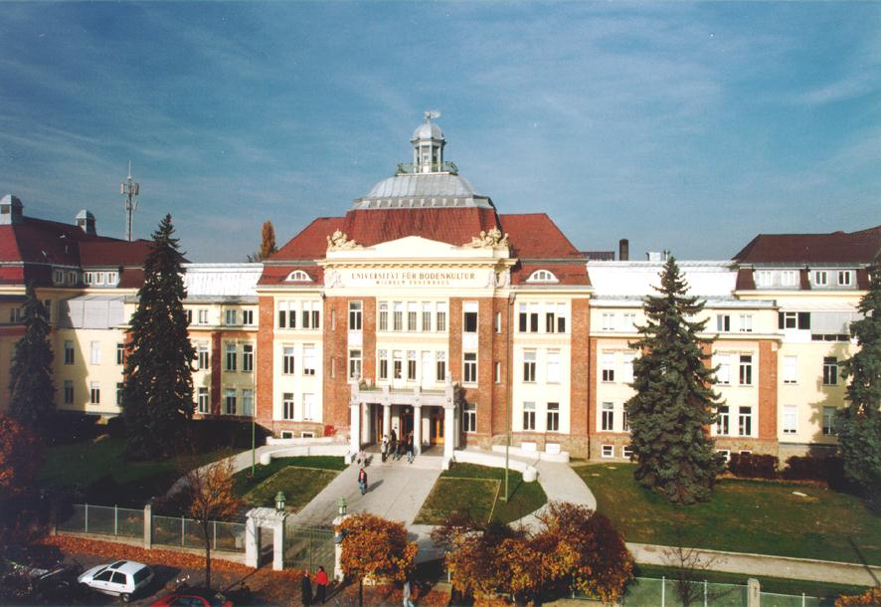
Figure 1: A sample figure caption. Use format Figure captions, letter style Arial 11 pt, italic, single line spacing with 6 pt spacing before paragraph.

Discussion
In this section you can answer research questions, explain conflicting results, unexpected findings, state limitations of the study, and so on.

Conclusions
Study results should be related to relevant literature. Furthermore, possible sources of error should be discussed and recommendations for future research can be made in this section.
ACKNOWLEDGEMENTS
A short section may acknowledge special assistance and sources of research funding.
References
Moons, T. (1997). Report on the Joint ISPRSS Commission II/IV Workshop “3D Reconstruction and Modeling of Topographic objects”, Stuttgart, Germany, http://www.radig.informatik.tu-muenchen.de/ISPRS/WG-III4-IV2-Report.html (accessed 28 Sep. 1999).
Smith, J. (1987a). This is a fictive book title. Elsevier, Amsterdam, pp. 123-124.
Smith, J. (1987b). This is an example of the title of a proceedings paper. In The International Archives of the Photogrammetry, Remote Sensing and Spatial Information Sciences, Kyoto, Japan, Vol. XXVII, Part B1, pp. 123-129.
Smith, J., Pettersson, D. and Andersson, C. (1990). This is an example of a fictive journal article name. Int. J. Remote Sens. 2:100-110.

