Venue of the Summer School at the Institute of Geotechnical Engineering
17th-18th August, 2018
Address: Feistmantelstrasse 4, 1180 Vienna
Room: SR-01, ground floor

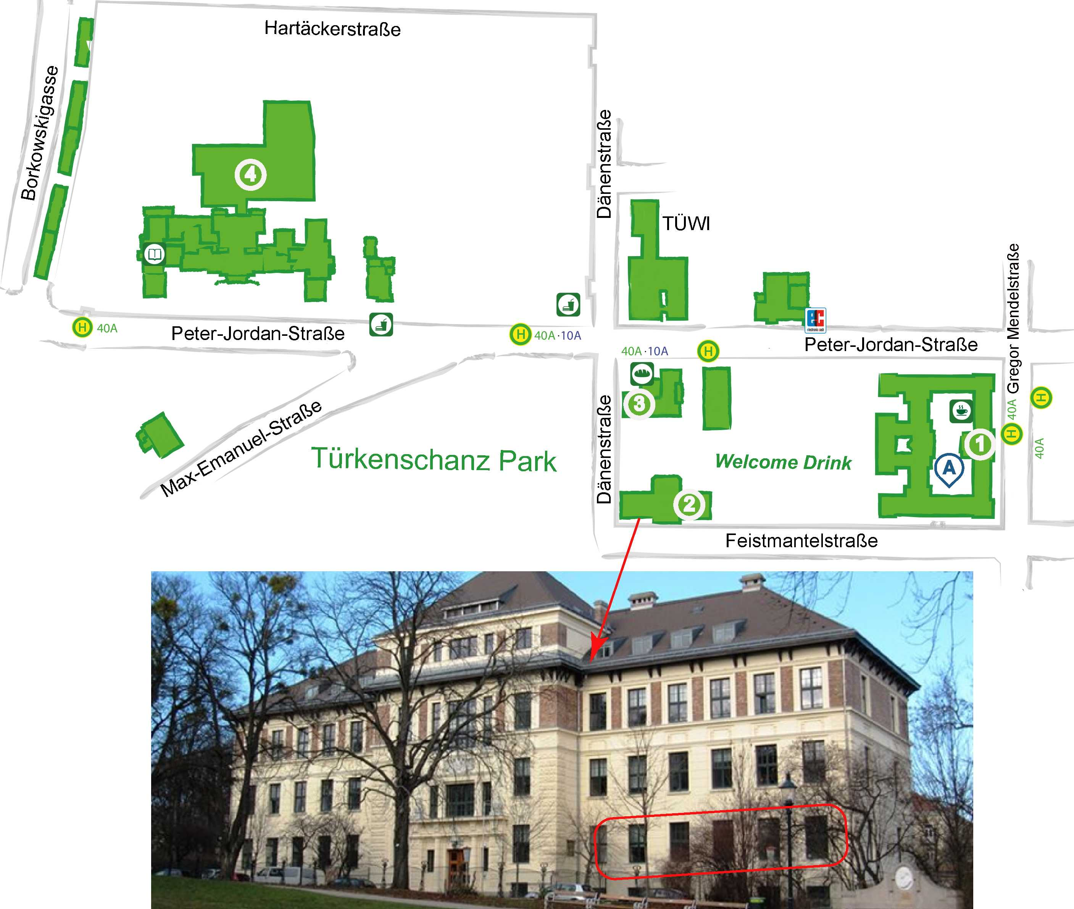

Institute of Geotechnical Engineering, Feistmantelstr. 4

