Master Thesis
This is a sample for the overall layout
of the cover page. The title should be concise,
to fit on max. 3 lines
submitted by
Student EXEMPLARY, BSc
in the framework of the Master programme
Water Management and Environmental Engineering
in partial fulfilment of the requirements for the academic degree
Diplom-Ingenieurin
Vienna, Month 202#

Supervisor | Co-supervisor
Univ.Prof.^{in} DI^{in} Dr.^{in} Helen Helpful  Institute of Layout and Typography  Department of Design  University of Natural Resources and Life Sciences, Vienna | Dr. Peter Supportive, MSc  Institute of Layout and Typography  Department of Design  University of Natural Resources and Life Sciences, Vienna

Master Thesis
This is a sample for the overall layout
of the cover page. The title should be concise,
to fit on max. 3 lines
submitted by
Student EXEMPLARY, BSc
in the framework of the Master programme
Climate Change and Societal Transformation
in partial fulfilment of the requirements for the academic degree
Master of Science
Vienna, Month 202#

Supervisor
Univ.Prof.^{in} DI^{in} Dr.^{in} Helen Helpful
Institute of Layout and Typography
Department of Design
University of Natural Resources and Life Sciences, Vienna
Co-supervisors
Dr.^{in} Fiona First, MSc  Institute of Layout and Typography  Department of Design  University of Natural Resources and Life Sciences, Vienna | DI Peter Supportive, PhD  Institute of Printing Technologies  Department of Mechanical Engineering  University of Natural Resources and Life Sciences, Vienna

The purple text in this document is giving you information on how to use this template. The blue text provides tips for formatting your document using Microsoft Word. Please make sure to delete most of the black, and all of the purple and blue text when you use the template for your master thesis.
You might want to use ‘show formatting marks’ (the ¶ button in your ribbon) to see the page breaks and the section breaks. Be careful when deleting section breaks, as this will affect formatting, esp. the footer with the page numbering.
Given that your master thesis will be mostly read on a computer monitor, rather than as a printed book, this document is formatted accordingly (i.e. odd/even pages are not mirrored, there is no ‘gutter’, etc.). It also means that no blank pages are inserted (e.g. to leave the backside of the cover sheet empty). This means if you are printing copies of your thesis, you might want to print the first few pages (those with page numbers i, ii, etc) on one side only (so that the text is always on the right page when you open the book). You may choose to print the remainder (i.e. starting on page 1) double-sided or one-sided.
Please select the appropriate cover page: if you list one or two (co-)supervisors, then use the first page. If you list three or four (co-)supervisors, then use the second page. When deleting the unneeded title page, be careful not to delete the section break at the bottom of p. 2. Please put your family name in CAPITAL letters, as this allows to ensure that it is clear under which letter to list your thesis (esp. if you have several first names and/or a double family name it may not always be clear how to list you alphabetically).
Academic titles are important in Austria, especially in a formal document submitted to a university. Please ensure that you include your previous academic titles and write them correctly:
- You must include your bachelor title, since you need to have completed a bachelor to be eligible for a master. Also include other academic titles you have been awarded. All academic titles listed on the cover page must be listed in BOKUonline.
- Make sure to check exactly which title you have been awarded, and use the official abbreviation, including where to insert full stops. So for example the Bachelor is abbreviated as either ‘BSc’ or ‘B.Sc.’ (you can consult an official website, e.g. with general information from the Austrian government or from the Federal Ministry in charge of universities).
- Make sure you insert your title(s) correctly before and/or after your name (e.g. DI before your name, MSc and BSc after your name, see the websites in the previous point).
- If you are awarded a ‘Diplom-Ingenieur’ and you identify as a woman, you are invited to use the feminine version, e.g. Diplom-Ingenieurin. But it is not compulsory.
- Academic titles are not translated, so please check the German version of your curriculum. If you are studying towards a Diplom-Ingenieur, this is what you should write on your cover page.
Please check the exact name of your Master Programme in the curriculum
For your supervisor, please consult the BOKU FIS and search for ‘Researcher’ to ensure that you use the correct titles and the exact wording of the institute and department.
If you want, you can insert a personalized (second) cover page after the mandatory front page (previous 2 pages) and before the affidavit (on the next page). You are completely free in how you design this second cover page, both regarding the text and the graphic design (e.g. using an illustration, a photo, a creative background).

Affidavit
I hereby declare that I have authored this master thesis independently, and that I have not used any assistance other than that which is permitted. The work contained herein is my own except where explicitly stated otherwise. All ideas taken in wording or in basic content from unpublished sources or from published literature, as well as those which were generated using artificial intelligence tools, are duly identified and cited, and the precise references included.
I further declare that this master thesis has not been submitted, in whole or in part, in the same or a similar form, to any other educational institution as part of the requirements for an academic degree.
I hereby confirm that I am familiar with the standards of Scientific Integrity and with the guidelines of Good Scientific Practice, and that this work fully complies with these standards and guidelines.
City, date First name SURNAME (manu propria)
The affidavit is a sworn statement, and is a binding assurance that you have actually done the things that are stated. A violation of the content of the statement may have legal consequences. The affidavit is thus not just a mere formality. Please leave ‘(manu propria)’ next to your name (it is Latin and means ‘[signed] with one’s own hand’). With it you confirm the authenticity of your sworn statement, despite the fact that you do not include a handwritten signature (which would be problematic in a pdf-file that is freely available for download).
Through the affidavit, you confirm that:
- You have adhered to all provisions of Good Scientific Practice and to the standards of scientific integrity (see BMBWF (2020) ‘Best practice guide for research integrity and ethics’).
- The purpose of this master thesis is to document your research performance. The readers thus need to be able to clearly identify your contribution. While working on your thesis, you have necessarily drawn on other’s work, but all the ideas of others need to be marked as such (i.e. adequately quoted, cited and referenced). You thus explicitly state that you have not plagiarized. Note that this includes self-plagiarism, i.e. copying or paraphrasing your own texts in a way that presents published ideas as if they were new, thereby misleading the reader.
- You confirm that you have properly identified and cited texts that were generated with the help of AI technology. If you have used AI tools (such as ChatGPT) to edit a text you have written, it is recommended to explain this in the 'Declaration regarding the use of generative AI tools' section.
- You also certify that you have not resorted to external help, e.g. in the form of ghostwriters.
- Some forms of assistance are allowed. This applies in particular to the mentoring by your supervisor not least regarding the research design, conception and data analysis. Assistance regarding the style, linguistic expression, and proof reading (i.e. correction of grammar and typographical errors) is also permitted if it does not change the content of your work. These contributions should be explicitly stated in the acknowledgements, thus making transparent what assistance you have received.
Note: this is where page numbering begins, with lower case roman numerals.

The following three pages (for dedication, epigraph, preface) are optional: you may or may not want to include them in your thesis. You might choose to include one, two or all three of these pages. If you want to include none, just delete them. Make sure you do not only delete the text, but also the page breaks, so that you do not have empty pages.
Include a dedication is if you want to dedicate this thesis to a person. The dedication is usually only a brief statement with the name(s) of (a) persons(s) you want to dedicate your thesis to. There is no explanation to why (as it is done in the acknowledgements), but you can include your relationship with the person (e.g. “This thesis is dedicated to my precious daughter Ellie.”).
This thesis is dedicated to…

An epigraph is a short quote that is particularly meaningful to you, and/or that you want to use to set the tone or suggest the theme of your research (see example below).
As for the future, the aim is not to predict it, but to enable it.
Antoine de Saint-Exupéry, Citadelle, 1948

Preface
In some cases, you might want to include a separate page in which you provide information on the broader context in which the thesis was written (in most cases this information is included in the acknowledgements, where the wording is less formal).
You can use a preface to refer to a larger research project, or a research program within which your research took place. On this page you can include the logo of an organisation that hosted you, or of the research project which funded your research (you cannot include that logo on the cover page). Below you find a few text bits that might help you formulate the preface.
This research was conducted with the generous support of the Austrian Federal Ministry of XYZ. Additional financial support for data analysis was provided by XYZ.
This research was financed by … and conducted at the Institute of …. over the period January 2021 to December 2024, in cooperation with ….
The research presented in this master thesis was conducted in the framework of the project “XYZ”, funded by XYZ (grant number: xxx)
This master thesis was funded by a fellowship of the XYZ and supported by the ACRONYM Project [Project number] from the Austrian Science Fund (FWF) and from the European Research Council (ERC) under the European Union’s Horizon 2020 research and innovation program grant agreement No. xxxxx.

Acknowledgements
The acknowledgements have two purposes: (1) to document and make transparent the assistance you have received and that is permitted (see the affidavit). You thus clarify that while this thesis is your work and yours alone, the research process throughout your research is a collaboration which covers many aspects of life in academia; and (2) to extend a ‘thank you’ to all those who have contributed in any way to your doctoral journey.
The acknowledgements thus usually cover three groups of people:
- your supervisor and colleagues who have provided scientific input in the design and implementation of your research and the interpretation of the results, especially through discussions;
- people who have helped you with the layout, wording, spelling, grammar, graphics of this master thesis;
- partners, family, friends, flatmates, colleagues, etc. who have provided you emotional, moral, material or financial support throughout the years of your studies.
It is a good idea to start this section early, to make sure you do not forget anyone...

Table of content
Affidavit i
Preface iv
Acknowledgements v
Table of content vi
Abstract vii
Kurzfassung viii
1. Introduction 1
1.1. How to use this template 1
1.2. Seeing the structure of your document 1
2. Methods or Some hints on formatting 2
2.1. Using the Styles for a consistent formatting 2
2.2. Format paragraphs 2
2.3. Formatting headings with/without numbering 3
2.4. Of figure captions and table titles 3
2.5. Section breaks and page breaks 4
2.6. Formatting your document so that it is accessible 5
3. Summary and Conclusions 7
References 8
Declaration of the use of generative AI tools 9
List of abbreviations 10
List of tables / figures 11
Appendix A: Survey 12

You will need to update the table of content manually: right click anywhere on the table and select ‘update field’.
As the table of content is aimed at providing an overview of the work, you might want to make it fit on one page, e.g. by selecting the number of levels included (possibly include only the first two levels), or by reducing the space between the lines (select the whole table and then go to Format > Paragraph > Spacing after: 0 pt)
Also, to make it easier for the reader to go to specific sections, it is good to ensure that when you save the file in pdf format, you ensure that links are ‘live’ (i.e. by clicking on an entry in the table of content, the reader is automatically taken to that section). Thus use the ‘create pdf’ option in the Acrobat tab, rather than File > Print > pdf.

Abstract
This should be the abstract in English as it will be included in the BOKU Abstracts-Database, see: https://short.boku.ac.at/w3gvv3. It should thus have max. 2.000 characters (incl. spaces) and be written as a single paragraph. The abstract should include a brief statement of the problem, the specific topic you addressed, a brief exposition of methods, and the most important results/findings of your research, as well as your conclusions. It would be desirable for the abstract to be comprehensible to scientists outside your particular field of research.

Kurzfassung
Abstract in German. This is a translation of the English abstract, with max. 2.000 characters, including spaces.

Introduction
This is where you start the text of your thesis. Delete this paragraph and start typing. If your text is purple, highlight the text and select the style ‘normal’ in the ribbon (see Figure 1). All following paragraphs will automatically have the style ‘normal’.
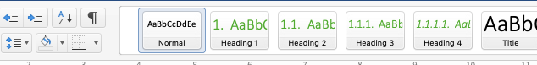
Figure 1: Selecting the style 'normal' for your normal text paragraphs
Note: this is page 1 (all previous pages are numbered using lower-case roman numerals), so be careful not to delete the ‘section break’ inserted in the previous page (use the ¶ button in your ribbon to show formatting marks).

How to use this template
This template is mostly aimed at providing you guidance on how to organise the various potential items in the ‘front matter’ (everything that comes before this introduction chapter) and the various potential items of the ‘back matter’ (everything that comes after your references). As an added bonus, the template includes some helpful hints for formatting your thesis using MS Word.
Thus, of this template,
- The cover page is compulsory (design and content), only change title of your thesis, name, academic title, advisor
- The organisation of the front matter is recommended
- Everything else is entirely up to you (e.g. the font you use, how you format the headings, whether you insert a header, etc.)

Seeing the structure of your document
To help you navigate the various sections in the document, you may select View > Navigation Pane, and then select the ‘document map’ (see Figure 2 ).
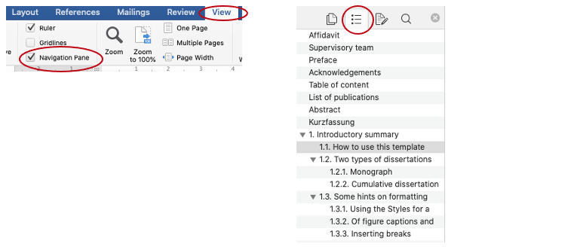
Figure 2: Making the structure of the document visible for easy navigation

Methods or Some hints on formatting

Using the Styles for a consistent formatting
You are of course entirely free to modify the font you use, how the headings look like, how much space you insert before/after a paragraph, how wide your margins are, etc. so as to suit your personal preferences and aesthetics. To ensure that the choices you make are applied consistently throughout the document, and thus giving it a polished look, it is strongly recommended to use the ‘Styles’. You find the styles either in your ribbon, or in your menu (Format > Style).
To change a style, you only need to right click on a style in the ribbon and select Modify (Figure 3). By modifying the formatting in this way, MS Word will systematically update all the text to which this particular style was applied (you see what style by placing your cursor anywhere in that paragraph and looking at which style is highlighted in the Style ribbon).
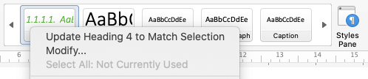
Figure 3: If you right click on a 'styles' in the ribbon you can modify it. You can also open the styles in a separate panel

Format paragraphs
Much of the body text will be of the Style ‘normal’. Within the body text, each paragraph should be clearly distinguishable, even if the last line goes until the right margin. To ensure this, you can either intend the first line, or insert a space before and/or after each paragraph (the way it is done in this template, where there is a 6 pt space after each paragraph).
Formatting your ‘normal’ paragraph this way is much more efficient than inserting e.g. a ‘hard return’ between paragraphs (select the show/hide tool (¶) in the ribbon to see where you are using ‘hard returns’ to create space). To modify the Style of the ‘normal’ paragraph (see Figure 4) to suit your preferences, use the feature Format > Paragraph > Space before (or after).
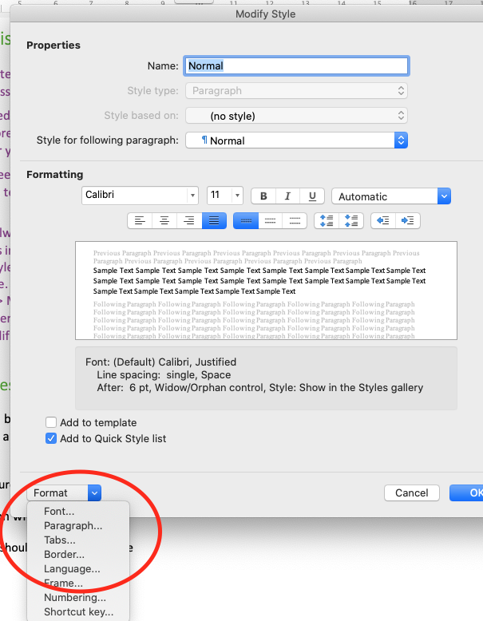
Figure 4: If you click on 'format', you can modify the appearance of the style you selected

Formatting headings with/without numbering
You should also use the ‘Style’ function to format the headings, including the space before/after each section headings. Usually, the higher-level headings have a larger font, and more space before and after the paragraph, compared to lower-lever headings.
You can also format other features of the ‘headers’. For example currently the style for ‘Header 1’ automatically inserts a page break before the header, so that each chapter starts on a new page. If you do not want that, then you just change it in the Style: right click on Heading 1 in the ribbon (see Figure 3) > Modify… > Format > Paragraph > unselect ‘Page break before’. This will ensure that all Header 1 are automatically modified, thus ensuring consistency throughout your thesis.
Note that much of the ‘front matter’ (i.e. Affidavit, etc.) are also using the Style ‘Heading 1’, however the numbering has been supressed (go to your ribbon and unselect the numbering, see Figure 5).

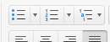
Figure 5: Position your cursor anywhere in your heading, then unselect numbering

Of figure captions and table titles
All figures and tables should be cited in the main text. Both figures and tables should be placed right after the paragraph in which they are first referred to, if they still fit on the same page. If not, you might move the figure on the next page, and move some text above the figure, so as to avoid a half-empty page. However the figure (or table) must still be part of the same section.
To ensure that your numbering is correct and that it updates even if you delete or insert a figure (or table) you must first insert a ‘caption’ and then use ‘cross-reference’ to refer to it in the text. To do so:
- insert your figure;
- right click on the figure, and from the drop-down menu select ‘insert caption’. Select the label type (‘figure’) and type the text of your caption (you might want to insert a colon (:) or a dot (.) to separate the figure number from the caption text);
- to refer to a specific figure in the body text, click on ‘insert’ in your menu, and select ‘cross-reference’. Then under ‘Reference type’ choose ‘Figure’, and then select ‘only label and number’
If you delete a table or a figure or insert one higher up, you need to manually update the references in the text. To do so, select all your text (Ctrl + A), then right click anywhere, then select ‘update field’ to ensure that the numbering of all tables and figures are updated. If you have referred to the deleted figure in your body text, MS Word will insert a “Error! Reference not found.” You will need to delete it manually, since it now refers to a figure that no longer exists.
You can modify the style of the captions just like you modify any other style (see Figure 4).
Note that the caption of a figure should be below the figure, the caption of a table should be above the table (see Table 1).
Table 1: The title of a table should be above the table
 | Column 1 | Column 2
Row 1
Row 2

Section breaks and page breaks
‘Breaks’ are an important formatting feature. There are two main type of breaks used in this template: section breaks, and page break. Section breaks (in the menu select ‘Insert’ > ‘Break’ > ‘Section break (next page)’) are most useful if you want to change the header or the footer. For example at the end of the page for the ‘Kurzfassung’ there is a ‘Section break (next page)’ which allows you to change the page numbering from lower case roman numerals to Arabic numbering, and to restart the numbering at 1. This is done by double clicking on the footer (where the page numbering is), then in the ribbon unselect the 'Link to previous’ icon (see Figure 6), and then go to ‘Insert > Page Numbers > Format > Start at 1.
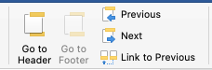
Figure 6: To change page numbering, you need to unlink a footer from the footer in the previous section
Page breaks are used as part of the Style of Heading 1, to ensure that each Chapter starts on a new page.
Do not use page breaks to keep text together (e.g. to ensure that two paragraphs stay on the same page). For this right-click anywhere on the paragraph, select ‘Paragraph…’ select the tab ‘Line and Page breaks’ and then select e.g. ‘keep with next’ (see Figure 7). This ensures that if you delete a larger chunk of text, the two paragraphs you want to maintain together, will move up, rather than you having a half empty page (which would be the case if you inserted a ‘page break’).
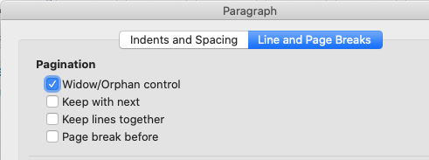
Figure 7: to ensure that two paragraphs stay on the same page, select 'Keep with next'
Note that all headings automatically ‘stick’ with the first paragraph, as they are formatted to ‘keep with next’.
To see where you have inserted section breaks or page breaks, select the show/hide tool (¶) in the ribbon.

Formatting your document so that it is accessible
The Directive (EU) 2016/2106 on the accessibility of websites, all pdf-documents that can be downloaded from a website should comply with the international standard PDF/UA (universal access). This enables them to be accessible to people who are visually impaired. A document is accessible if it is formatted in such a way that a screen reader app can render the information correctly as speech or braille output. Screen readers ‘linearize’ the (visual) information on the screen, i.e. they read the information from left to right and from top to bottom. For such programs to be able to reproduce the information in the right order, it is necessary for the formatting of the Word document to make it clear what is to be read when and how.
For your dissertation to be as accessible as possible, it is helpful to format it accordingly, i.e:
- The structure of your document should be clear: just because a text looks big, bold and cantered, it is not a heading for a screen reader. By using the Styles, the headings are ‘tagged’ and thus recognizable as such by the screen readers. Style sheets also reflect the hierarchy of the content (headings, body text), so that visually impaired people can navigate through the text instead of having to wait for the screen reader to read everything in order.
- Larger spaces between paragraphs or before/after a heading should never be created by blank lines (these are read by screen readers as 'blank line' or 'blank paragraph'). To create spacing, either use the format templates or define the spacing for an individual paragraph (Format > Paragraph > Space before/after).
- Some visually impaired people cannot see images. Therefore, the content and intention of each figure should be described with a short text (80-120 characters of alternative text – alt text). Simply right-click on an image and select 'Edit Alt Text'.
- Figures must be included using the 'In line with text' option, otherwise they may not be read in the correct order (Picture format > Wrap text > In line with text)
- Images that are purely decorative should be marked as such (right-click image > edit alt text > check box) then they will not be read out. It should be noted that information in the header and footer is automatically marked as 'decorative' and is therefore not read out.
- In tables, avoid using merged cells, since the reading order becomes unclear. Tables should not be used as a design element or for formatting.
- The Word file should include metadata, especially with the title and author name (File > Properties).
MS Word can help you identify weaknesses in accessibility (Review > Check Accessibility). MS Word can also read the text aloud (Review > Read Aloud). The free PDF Accessibility Checker (PAC) can be used to check whether a PDF file meets the PDF/UA criteria.
For more information on the subject of making documents accessible, see e.g. the corresponding MS Word website.

Summary and Conclusions
This is where you can provide an extended abstract of your whole thesis. This is particularly useful if you have included a short abstract (i.e. kept to the max. 2.000 character-limit of the BOKU Abstracts-Database). It provides a 2-3 pages summary of your work, including:
- The motivation driving your thesis, i.e. what topic did you choose? Why did you choose it? Why is this issue/problem relevant? For whom?
- The specific purpose of your research, i.e. what research question(s) you addressed (which is narrower than the overall topic)
- How you addressed it, i.e. what methods you used, what data you collected
- What your results are, i.e. the answers to the research questions
- The significance of your research, i.e. what new insights have you generated? What contribution does your thesis make to the literature? How as it advanced the state of knowledge?
This summary should be convincing, providing a concise statement on how you have contributed to the state of the art, and that your research is worthy of a master thesis.

References
This is where you include all the references to the publications you have cited.
Use the reference style that is common in your discipline. It is helpful to use a reference manager (e.g. EndNote, Citavi, Mendeley) to ensure that all references in the text will be included in the reference list. Please still check if each reference has all the bibliographic details (many of the reference managers ‘automatically’ extract the bibliographic information the pdf file of a paper, however, this is not fool proof!).
Ensure that each reference can be found easily, e.g. by using a ‘hanging indentation’ (see Figure 8: Format > Paragraph). This ensures that the name of the first author can be found easily (see below). You can also use the predefined Style ‘References’, however note that using that style will delete any additional formatting, e.g. the use of italics for the journal or book title.
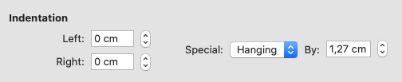
Figure 8: Format paragraph using a hanging indentation
Jaksic, D; Sertic, M; Kifer, D; Kocsube, S; Turk, AM; Nigovic, B; Sarkanj, B; Krska, R; Sulyok, M; Klaric, MS (2021). Fungi and their secondary metabolites in water-damaged indoors after a major flood event in eastern Croatia. Indoor Air 31(3): 730-744. https://doi.org/10.1111/ina.12777
Mairinger, T; Loos, M; Hollender, J (2021). Characterization of water-soluble synthetic polymeric substances in wastewater using LC-HRMS/MS. Water Res. 190, 116745. https://doi.org/10.1016/j.watres.2020.116745
Papathoma-Kohle, M; Thaler, T; Fuchs, S (2021). An institutional approach to vulnerability: evidence from natural hazard management in Europe. Environ Res Lett. 16(4), 044056. https://doi.org/10.1088/1748-9326/abe88c

Declaration of the use of generative AI tools
The field of Artificial Intelligence (AI) applications is evolving rapidly. AI offers new possibilities and also poses new challenges. In the context of a master's thesis, text-generating AI tools (such as ChatGPT) can play a pivotal role. However, it is crucial to use such AI tools with careful consideration and responsibly (see BOKU Framework for Dealing with Text-Generating AI Systems: https://short.boku.ac.at/KI).
Good scientific practice requires that all contributions of others to your thesis be identified as such. Texts generated with the help of AI do not qualify as your independent work and, therefore, should be clearly identified, just as you would when citing scientific literature. In other words, texts generated with the help of AI tools but not identified as such would be considered as plagiarism. This applies to all texts that were written about without significant effort on your part, i.e., both literal or paraphrased use of text generated by an AI tool. The afidavit also refers to the use of generative AI tools.
However, AI tools can also be used to revise text you have written, for example:
  - To structure or organize your text
  - To generate drafts for section headings or the title of the thesis
  - To create a rough draft of the abstract
  - To list the key statements of your work for the conclusions
  - To translate the abstract
  - To linguistically enhance text passages
We recommend that you make this legitimate use of AI tools transparent, not least to counter potential accusation – in the event of scrutiny through plagiarism software or AI detectors – that (a part of) your master's thesis was authored by an AI tool.
Thus, in this section briefly summarize which AI tools you have used and for what purposes. This can be done in great detail (see, for example, the table in Gimpel et al. 2023; weblink) or summarily, for instance: "In writing this master's thesis, I used Grammarly to rectify grammatical and orthographic errors. I used ChatGPT to enhance the stylistic elements of some formulations in my text. Moreover, I used DeepL to translate an initial version of the German abstract, using the English abstract that I had previously written."
If you have used AI tools to generate figures and the like, we recommend that you note this beneath the figure or as a footnote.

Further reading:
Gimpel, H., P. Dilger, L. Lämmermann, N. Urbach (2023). COGNISANCE: Declaration of generative AI tool usage in higher education tests. Research Center for Information Management, University of Hohenheim. (weblink)

List of abbreviations
This section is optional. If relevant include a list of abbreviations and/or acronyms. This is mostly necessary if you are using many and/or uncommon abbreviations. If you only use a few abbreviations or only common abbreviations (e.g. EU for European Union), it is sufficient to spell them out the first time you use them in the Introductory summary.

List of tables / figures
This section is optional. Lists of tables and figures can be included, if you feel these are helpful to the reader. For this you need to use the tool ‘add caption’ under references in MS Word to add figure captions (see section 2.4), this then allows MS Word to generate a list with the captions of all figures.

Appendix A: Survey
This section is optional. This is where you include additional material that you referred to in the text, e.g. survey questions, interview schedule.

