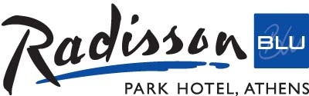

ACCOMMODATION FORM

“3rd AUEB ERASMUS STAFF TRAINING WEEK”
JUNE 22-26 2015

Please complete and return to hotel to: Anna.agrafa@rbathenspark.com or - Fax: +30 210-8238420 (Availability offered on request)

Name of guest_______________________________________________
e-mail:_______________________tel:_____________________

DATES:
Arrival________________ Departure________________

STANDARD deluxe rooms (1st to 4th floors):
Single occupancy _____ Euro 150,00 room / day
Double occupancy _____ Euro 160,00 room / day
SUPERIORS (5th and 6th floors):
Single occupancy _____ Euro 170,00 room / day
Double occupancy _____ Euro 180,00 room / day

*Room rates include:
-Super breakfast-Rich buffet breakfast as per Radisson Standards.
- WiFi Internet Use
-Use of the fitness centre/use of the swimming pool
-All taxes

In order to guarantee reservation hotel requires credit card details.

Credit card holder________________________________________
Credit card nr____________________________________________
Expiration Date___________________________________________

*Credit card will be charged a ONE night stay for any cancellation received
from and after June 25th 2014 and TWO nights stay in case of non-show.

I hereby accept above terms & conditions.

Signature of client: _________________________________

RADISSON BLU PARK HOTEL- 10 Alexandras Avenue, Athens 10682, Greece
Tel: +30 210 8894500, Fax: +30 210-8238420,
Site: www.rbathenspark.com / www.rbathenspark.com

