International Cycling Conference 2017
19. – 21. September 2017
Mannheim/ Germany

Call for papers & presentations

Deadline: 16 December 2016
To celebrate 200 years of cycling, the PASTA (Physical Activity Through Sustainable Transport Approaches) project, together with the German Environment Agency (UBA) and other partners, is currently running an open Call for Contributions to the 2017 International Cycling Conference, which will take place from 19 – 21 September in Mannheim (Germany).
The PASTA final conference will be held as part of this event on 20 September.
The Conference aims to bridge the knowledge and expertise of those working in research with transport and health practitioners, giving the opportunity to showcase good practice and discuss how physical activity can be better integrated into our everyday travel routines, for a more active, healthier Europe.
The Call for Contributions in the form of papers and sessions is structured around the following topics:
- Determinants of cycling and walking,
- Impacts of cycling and walking,
- Strategies and policies for promoting cycling and walking,
- Mobility cultures,
- Governance, stakeholders and networks,
- Developing technologies in transport and the future impacts.
Cities and researchers with experience and expertise in these areas are invited to respond to the call.
Full details see https://www.umweltbundesamt.de/en/international-cycling-conference-startseite
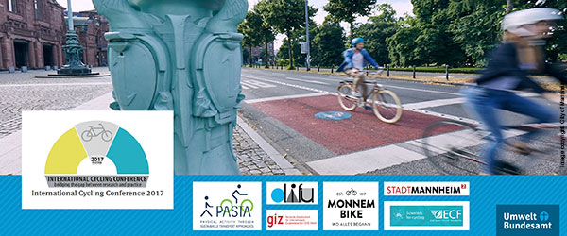
www.pastaproject.eu

