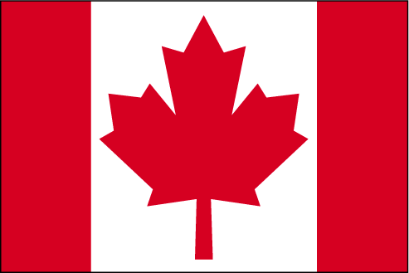

TRANSFOR-M APPLICATION FORM

„TRANSatlantic FORestry MASTER“

(please type it)

Last Name
First Name
Sex | ○ female ○ male
Date of Birth
Nationality
Private Address

Telephone
E-Mail
Present (or last) University attended
Present (or last)
study program
Current Semester
Bachelor or other exam taken (please specify!)
Level of English
language skills
Student activities (involvement in associations or organisations)
Areas of special interest in forestry and environmental management
Preferred  European University | 1.  2.  3.
Preferred  Canadian University | 1.  2.  3.
Master year abroad  (at host university) | ○ 1st ○ 2nd ○ 2019/20 ○ 2020/21  ○ 2021/22 ○ 2022/23
_____________________  (Date) | (Signature)

Please attach:
1. Motivation letter (not more than two pages)
2. CV (use the respective form)
3. Unofficial academic transcripts of current and previous degrees
4. Evidence of English language skills (for non-native speakers)
Submit by email to your TRANSFOR-M Advisor before the deadline!
Two letters of recommendation (form) should be sent directly from referees to the advisor!
Note: For UBC three recommendation letters are needed.

