Horiba XploRATM INV Raman microscope

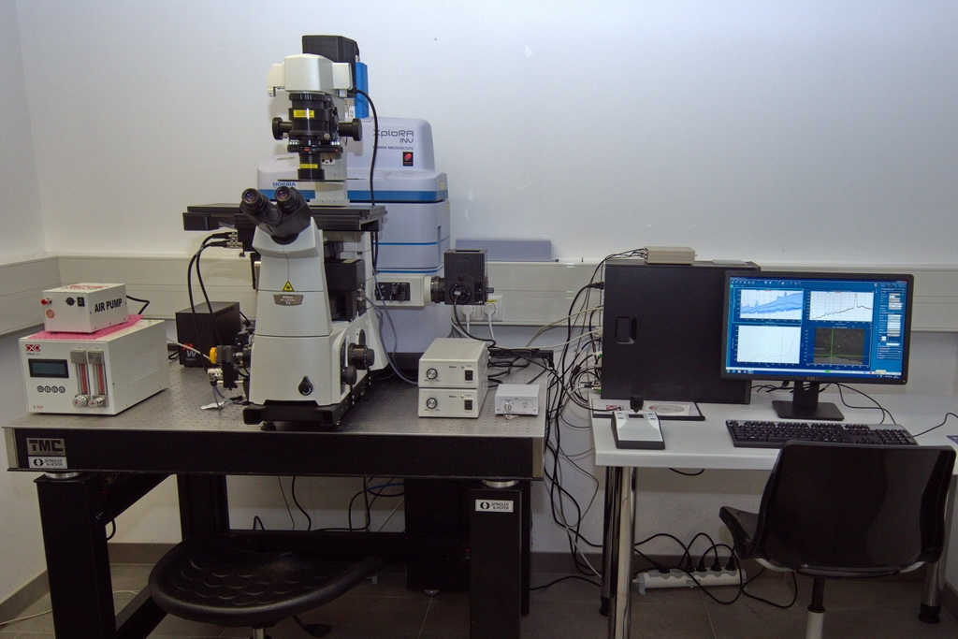

Microscope stand: Nikon Eclipse TiU
Stage: motorized with a Okolab UNO PLUS incubation system
Lasers: 532 nm (SS; 100mW)
785 nm (Diode; 90 mW)
NDD set: 100%, 50%, 25%, 10%, 1%, 0.1%
Gratings: 600 gr/mm, 1200 gr/mm, 1800 gr/mm, 2400 gr/mm
EMCCD (TE cooled); 1600 x 200 pixel; fromt illuminated

Objectives (default set):

Plan Fluor EPI 5x/0.15 Dry, WD=23.5 mm (ZK-5XVIS)

Plan Fluor 10x/0.3 Dry, WD=15.2 mm (10X-INV-TiU)

CFI Apo Lambda S 40x/1.15 Water, CORR WD=0.6 mm (ZK-40XLWD IM-W-TiU)

CFI Plan APO 100x/1.4 Oil WD=0.13 mm (ZK-100XIM-ÖL-TiU)

+ Objective for Autocalibration (all gratings + all laser lines)

